Elastic File System:

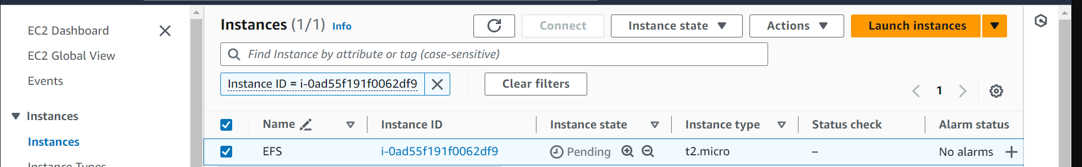

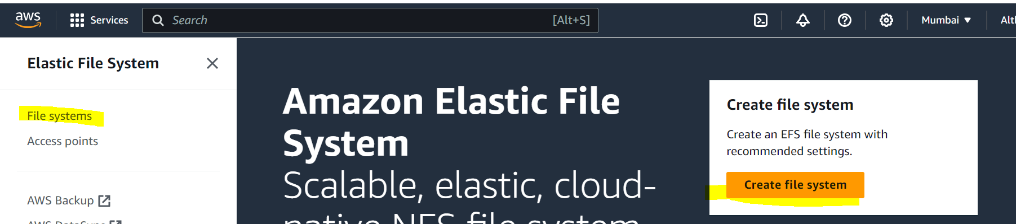

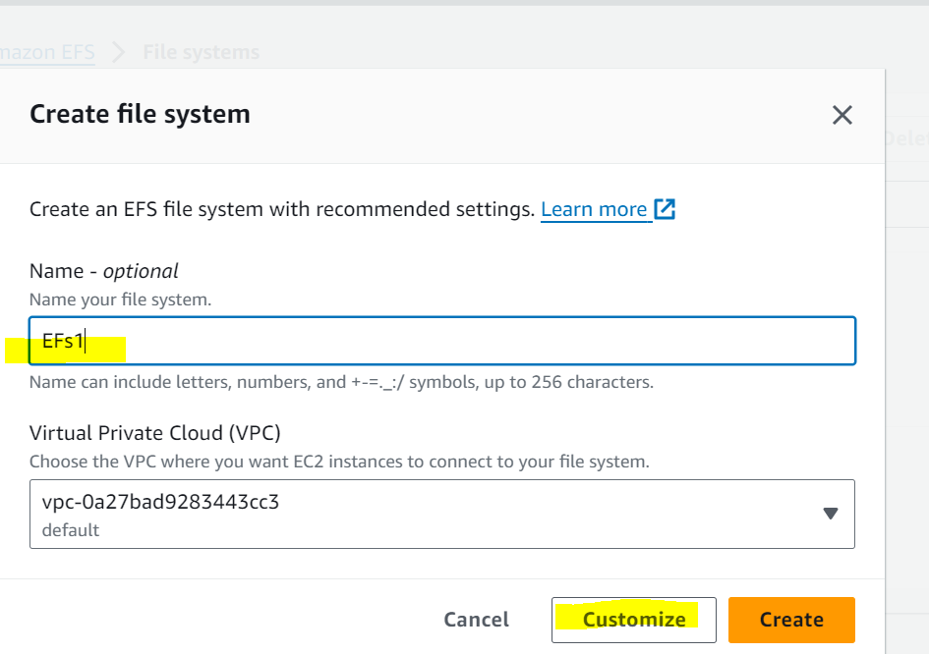

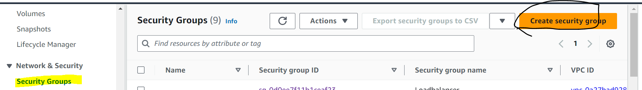

**When creating security group in inbound rule create NFS traffic, and add Ec2 instance security group Id which you created** .

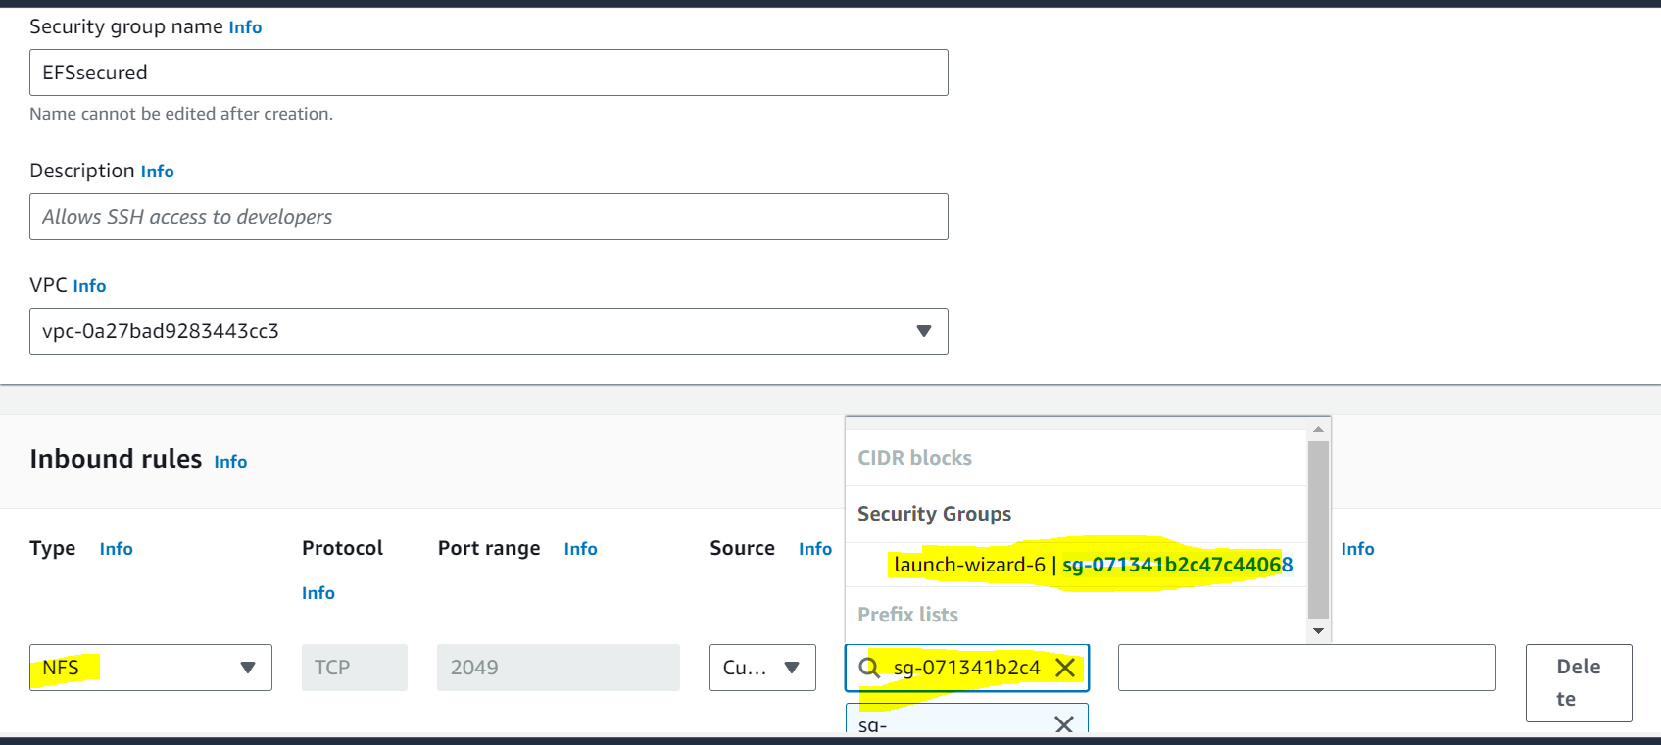

Go to EFS and add the security group id which you created above

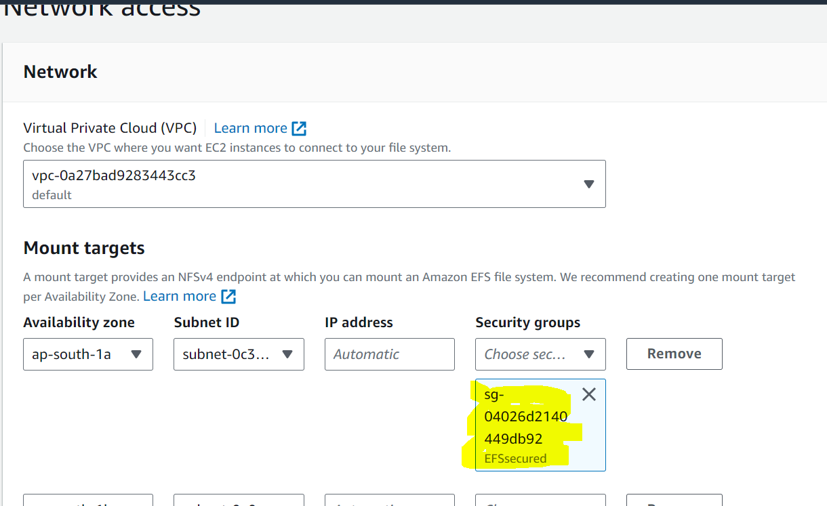

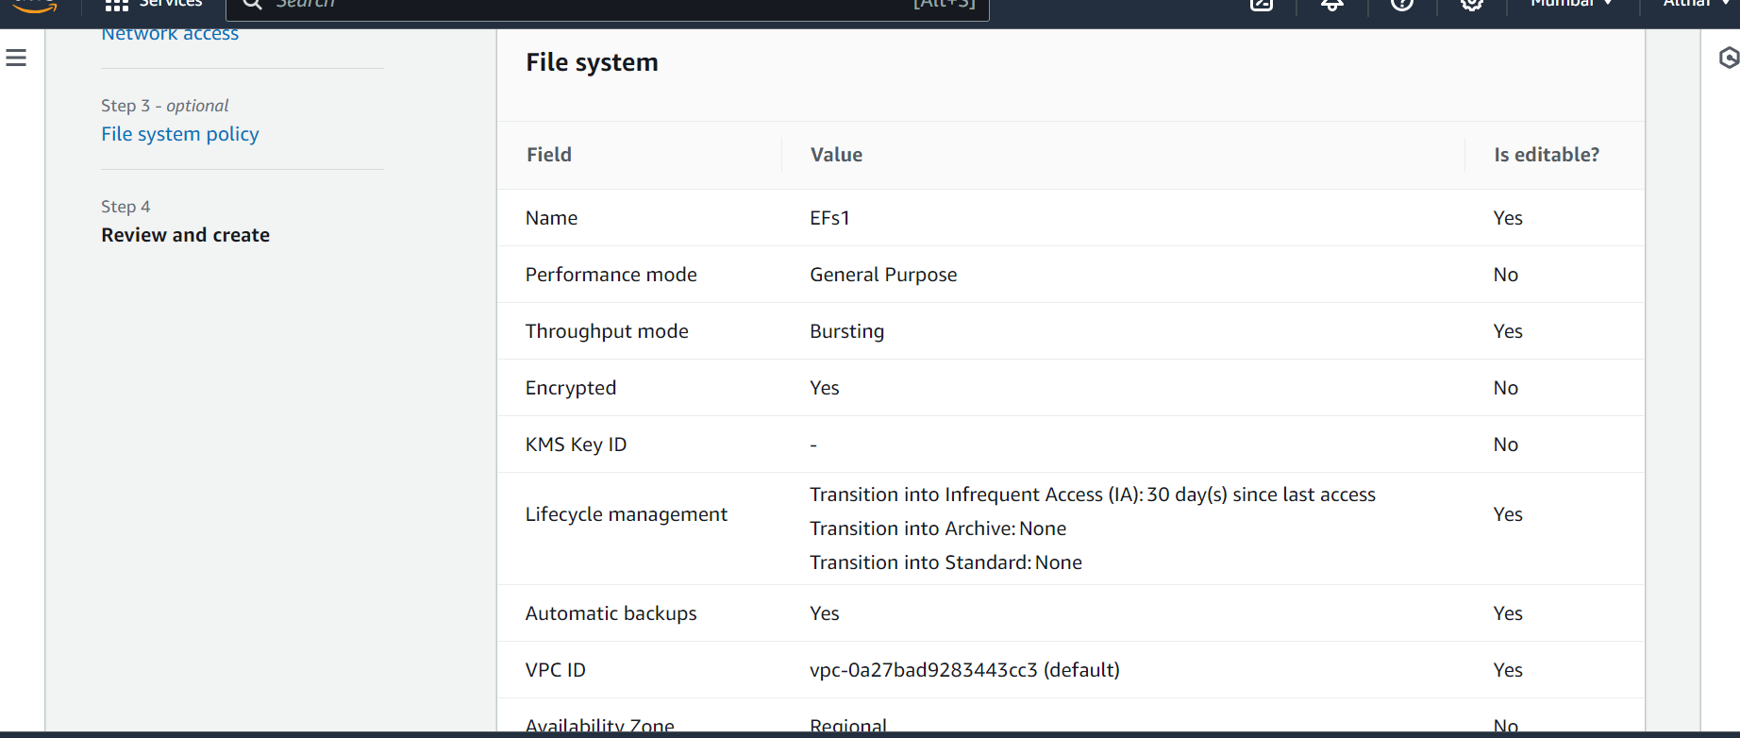

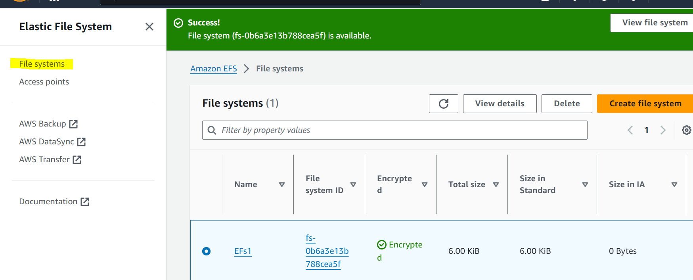

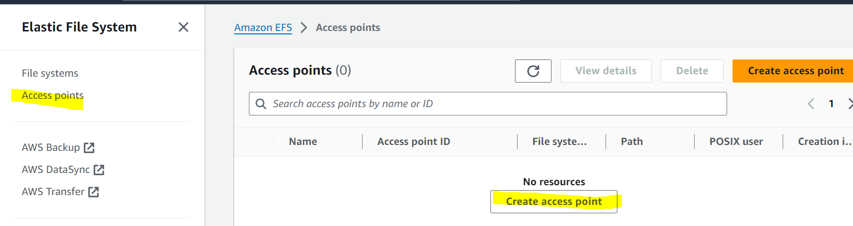

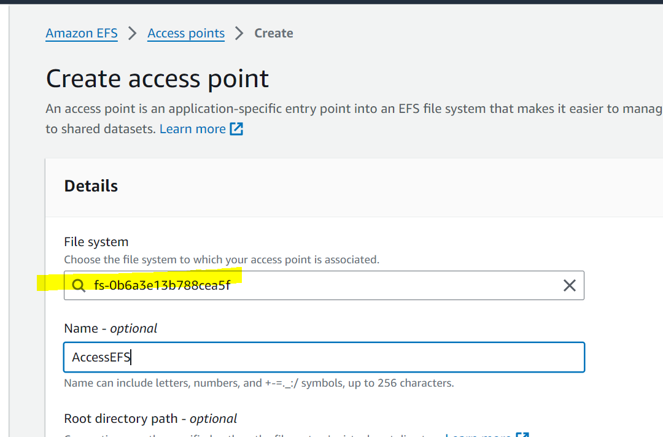

Create Access point

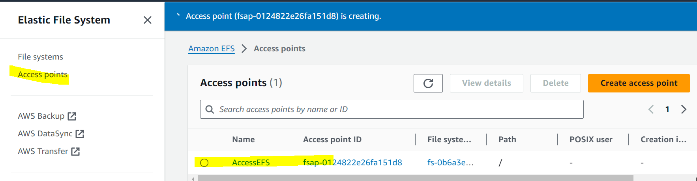

Install the amazon utility

[ec2-user@ip-172-31-39-252 ~]$ sudo -i

[root@ip-172-31-39-252 ~]# cd /etc/fstab

